Woxsen University
School of Technology

PROJECT REPORT
on
FACULTY WORKLOAD AND TIMETABLE MANAGEMENT SYSTEM
Design and Implementation of a DBMS-Based Web Portal for Workload Balancing and Clash-Free Scheduling
Name: Shaik Abdul Raheem
Roll Number: 25WU0102250
Course: Database Management Systems (DBMS)
Faculty Name: Dr. Kiran Mayee
Academic Year: 2025–2026

Abstract
The Faculty Workload and Timetable Management System is a modern, responsive academic web portal designed for university administrators, department coordinators and faculty members. It brings the management of faculty teaching workloads, curricular offerings, facility occupancy and weekly timetables into one centralized platform.
The system provides an executive dashboard with live key performance indicators and interactive charts, full CRUD management of faculty and subjects, an automated workload-balancing recommendation engine, and a weekly timetable matrix with real-time detection of faculty, room and section conflicts. It also includes classroom and laboratory management, department profiles, exportable audit reports, and role-based access control for three user roles.
As a DBMS course project, the application additionally showcases a Third Normal Form (3NF) relational model, a complete ANSI SQL DDL script, and an interactive SQL query simulator that demonstrates aggregation, self-join and multi-table join queries against the underlying data.
Keywords: Timetable Management, Faculty Workload, Conflict Detection, Relational Database, 3NF, SQL, RBAC, Web Application.

Table of Contents

1. Introduction

1.1 Background
Universities must continuously coordinate faculty availability, course requirements, classroom capacity and student cohorts. When this coordination is done manually or through scattered spreadsheets, it frequently results in overloaded instructors, idle capacity, double-booked rooms and overlapping classes for the same student group.

1.2 Problem Statement
There is a need for a single, centralized system that can record faculty, subjects, rooms and sections, measure each instructor's teaching load against permissible limits, and generate weekly timetables that are guaranteed to be free of clashes.

1.3 Objectives
- To build a centralized portal for managing faculty, subjects, rooms, departments and timetables.
- To monitor faculty workload against defined thresholds and recommend rebalancing where necessary.
- To prevent faculty clashes, room double-booking and section overlaps in real time.
- To design a normalized (3NF) relational schema with primary and foreign key integrity.
- To provide role-specific views for administrators, coordinators and faculty.
- To generate auditable reports exportable to CSV/Excel and print/PDF.

1.4 Scope
The system covers four academic departments (CSE, AI & ML, ECE and Mathematics), a six-day teaching week (Monday to Saturday) with one-hour slots between 9:00 AM and 5:00 PM, and a designated lunch break from 1:00 PM to 2:00 PM. It runs entirely in the browser with data persisted locally, making it easy to demonstrate and deploy.

2. System Overview and Technology
The application is a client-side single-page web application organized into a main shell, a state store, a router/controller and independent view modules. Data is stored in the browser, so no server-side database is required to run the demonstration.
Component | Technology / Details
Markup | HTML5 application shell with header, sidebar and modals
Styling | CSS3 with design tokens, dedicated timetable and component stylesheets, dark/light themes and an @media print stylesheet
Logic | Vanilla JavaScript organized as data, store, controller and view modules
Visualization | Chart.js for bar, doughnut and trend charts
Persistence | Browser localStorage with one-click reset to seed data
Hosting | Any static web server (e.g., Python http.server) or direct file open
Table 1: Technology stack

3. Functional Modules
The portal is divided into ten functional modules, each implemented as a separate view. They are described below.

3.1 Executive Academic Dashboard
The dashboard gives administrators an at-a-glance view of the institution through real-time KPI counters and interactive charts.
- KPI metrics: total faculty, active subjects, weekly scheduled classes, lecture halls and labs, average faculty workload, overloaded faculty (>16 hrs) and underloaded faculty (<11 hrs).
- Faculty Workload Distribution: multi-bar chart comparing actual contact hours against maximum permissible limits.
- Department-wise Workload Share: doughnut chart across CSE, AI & ML, ECE and Mathematics.
- Weekly Class Load Distribution: trend of class density from Monday to Saturday.
- Today's Live Schedule: feed showing time, subject, faculty avatar, room, section and session type (Lecture or Lab).
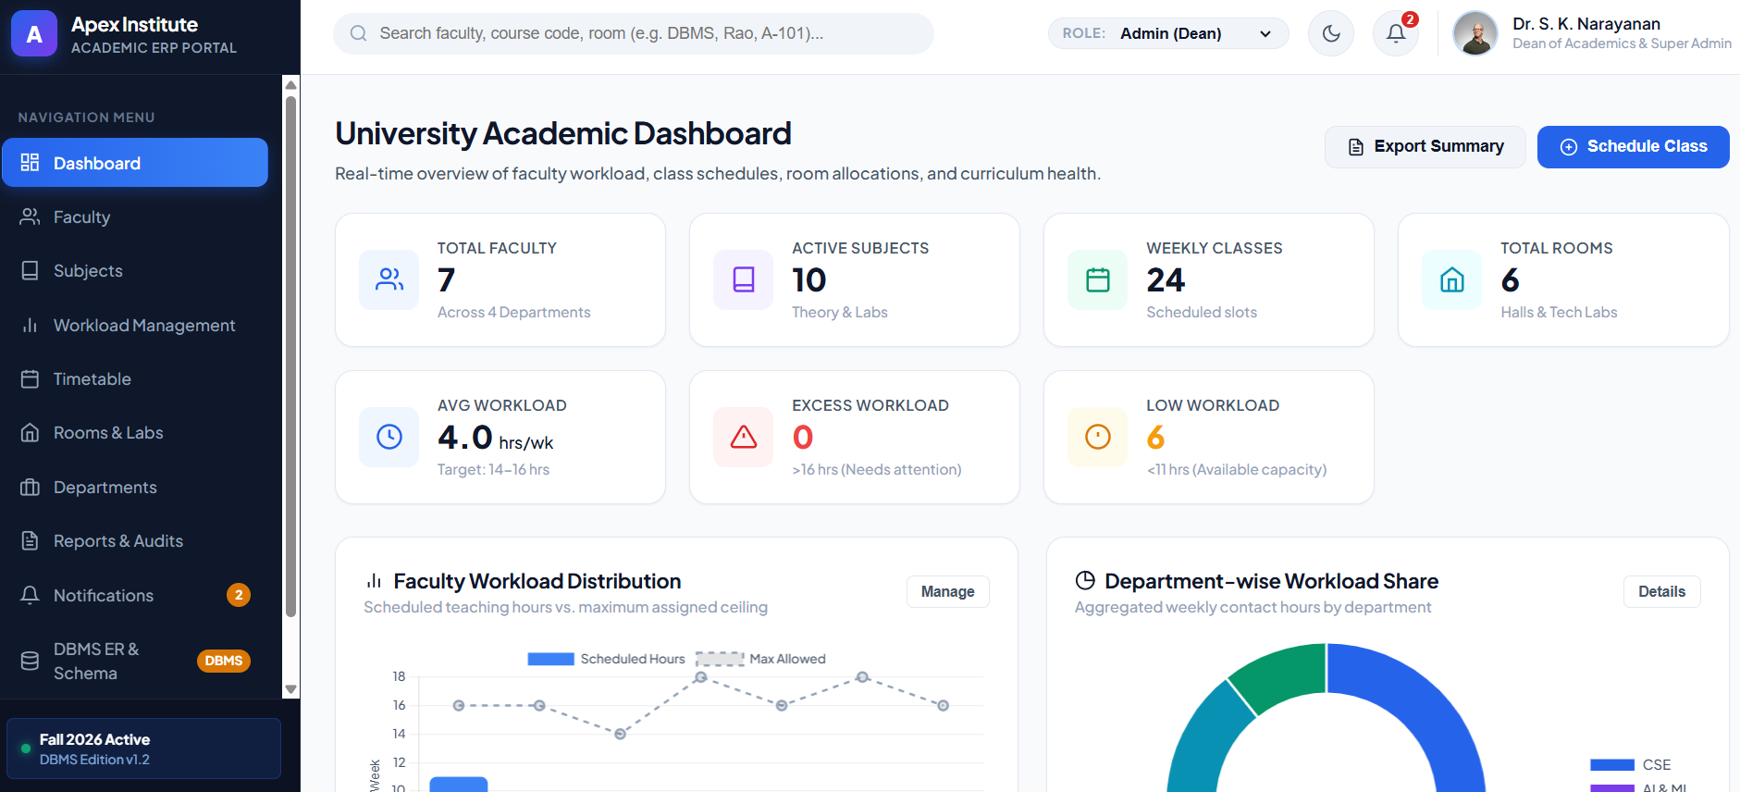
Figure 1: Executive Academic Dashboard with KPI cards and workload charts

3.2 Faculty Management and Directory
A comprehensive directory tracks Faculty ID, name, department, designation, assigned subjects, a colour-coded workload progress bar, maximum workload and status.
- View Profile: modal with contact details, research specialization and full weekly teaching timetable.
- Add / Edit Faculty: validated forms with automatic avatar generation.
- Assign Subjects: toggle interface to allocate or detach subjects.
- Delete Faculty: cascade protection that removes the associated timetable allocations.
- Search and Filters: instant text search, department filter and workload-status filter.
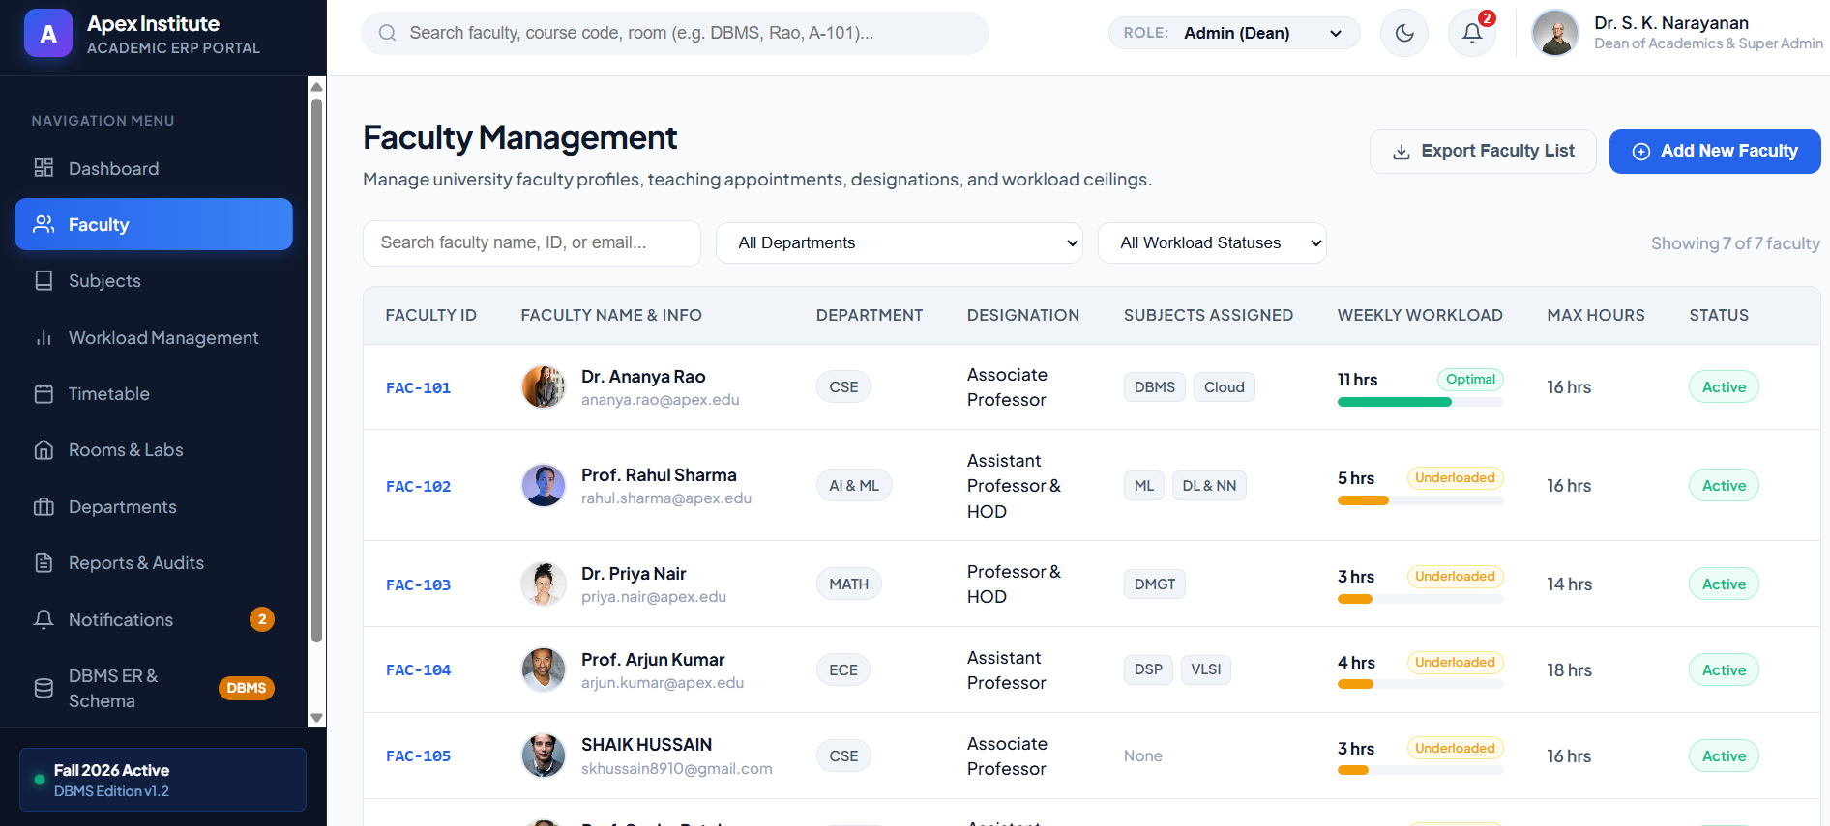
Figure 2: Faculty Management directory with workload progress bars and status

3.3 Curriculum and Subject Management
A tabular registry lists course code, title, department, semester, credits and the L-T-P (Lecture-Tutorial-Practical) contact-hour breakdown. Each subject is linked to its assigned faculty and total weekly teaching commitment, with full Add, Edit and Delete workflows.
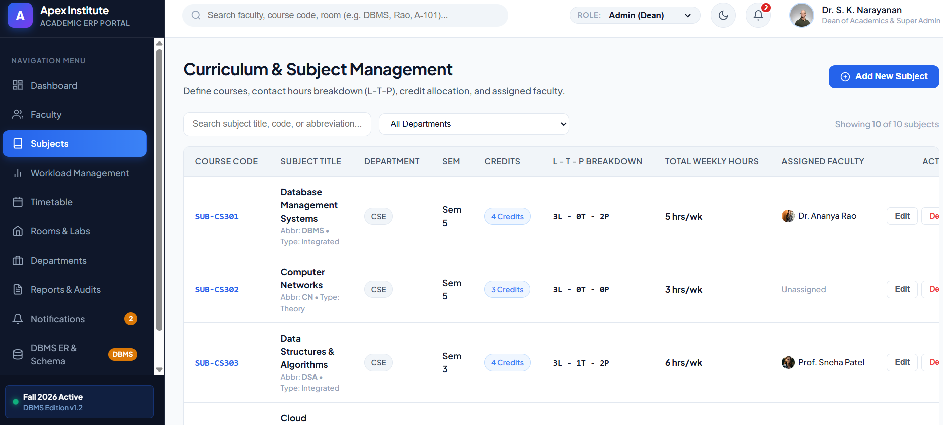
Figure 3: Curriculum and Subject Management with L-T-P breakdown

3.4 Workload Management and Allocation
This module compares actual teaching hours with permissible limits and classifies each faculty member using the thresholds below.
Status | Weekly Hours | Meaning
Optimal (Green) | 11 to 16 hours | Balanced teaching load
Overloaded (Red) | More than 16 hours | Exceeds the permitted threshold
Underloaded (Amber) | Fewer than 11 hours | Available teaching capacity
Table 2: Workload classification
An automated recommendation engine detects overloaded faculty and suggests peers in the same department who have spare capacity to take over course reassignments.

3.5 Interactive Timetable Matrix
The timetable is displayed as a weekly grid with days from Monday to Saturday and one-hour slots from 9:00 AM to 5:00 PM, with the 1:00 PM to 2:00 PM lunch break clearly marked. It supports three viewing modes:
- By Section: schedules for sections such as CSE 5A, CSE 5B, AIML 5A and ECE 5A.
- By Faculty: a personalized timetable for any instructor.
- By Room: occupancy schedules for lecture halls and computer labs.

3.6 Real-Time Conflict Detection Engine
Whenever a class is scheduled, the system validates it against the existing timetable and displays a warning banner describing the exact collision.
Conflict Type | Rule Enforced
Faculty Clash | An instructor cannot be assigned to two classes in the same time slot.
Room Double-Booking | A room or laboratory cannot host two classes at the same time.
Section Overlap | A student cohort cannot have two overlapping classes.
Table 3: Timetable conflict rules

3.7 Classroom and Laboratory Management
Room cards and an inventory cover lecture halls, computer labs, AI and data labs, and seminar halls. The module tracks seating capacity, building and floor location, projector or smart-board technology, live occupancy (Available or Occupied) and weekly utilization rate.
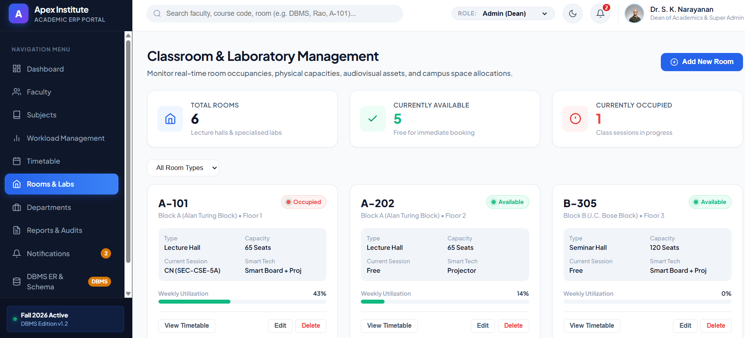
Figure 4: Classroom and Laboratory Management with live occupancy and utilization

3.8 Academic Departments
Institutional profiles for CSE, AI & ML, ECE and Mathematics present the Head of Department, the enrolled student body, the faculty roster and the aggregate departmental workload average.

3.9 Reports and Document Exports
A report generator produces four audit documents:
- Faculty Workload Compliance Report
- Departmental Academic Load Summary
- Master Timetable Digest
- Room Utilization Index
Reports can be exported with one click to CSV/Excel, or printed/saved as PDF using a clean print stylesheet that hides navigation and optimizes tables for Letter and A4 paper.

3.10 Notifications and Settings
A notification inbox surfaces priority alerts, while the settings module manages university parameters and workload rules and provides a Reset Sample Data option that restores the original seed database.

4. Database Design (DBMS Component)
The portal doubles as a DBMS course showcase. Its data layer follows a Third Normal Form (3NF) relational model in which each entity has a primary key (PK) and relationships are enforced with foreign keys (FK).

4.1 Relational Entities
Entity | Purpose
DEPARTMENT | Stores academic departments such as CSE, AI & ML, ECE and Mathematics.
FACULTY | Stores instructors and their department, designation and maximum workload.
SUBJECT | Stores courses with code, credits, semester and L-T-P hours.
ROOM | Stores lecture halls, labs and seminar halls with capacity and facilities.
CLASS_SECTION | Stores student cohorts such as CSE 5A and AIML 5A.
TIMETABLE_ENTRY | Links faculty, subject, room, section, day and time slot for each scheduled class.
Table 4: Core relational entities

4.2 ANSI SQL DDL Script
The application provides a copyable ANSI SQL script that creates all tables and integrity constraints. The script is portable across MySQL, PostgreSQL and Oracle.

4.3 Interactive SQL Query Simulator
The built-in simulator executes relational queries live against the project data. Three representative queries are provided.
No. | Query | SQL Concept Demonstrated
1 | Faculty Workload Aggregation | GROUP BY with HAVING to total weekly hours per instructor and filter by threshold
2 | Room Collision Detection | SELF JOIN on the timetable to find rooms booked twice in the same slot
3 | Department Resource JOIN | Multi-table JOIN combining departments, faculty and subjects
Table 5: Sample SQL queries

5. Role-Based Access Control
Users can switch roles from the header selector. Each role sees only the modules relevant to its responsibilities.
Role | Access
Central Admin (Dean) | Unrestricted access to all ten modules and the DBMS Schema Workbench.
Department Coordinator (CSE) | Department-focused management of faculty, workloads, timetables and reports.
Faculty Member | Personal portal with My Dashboard, My Timetable, My Workload and My Subjects.
Table 6: User roles and permissions

6. User Interface and Data Persistence
- Theme: built-in dark and light modes with smooth transitions.
- Responsiveness: layout adapts to desktop and smaller screens.
- Persistence: all additions, edits and deletions are saved to localStorage and survive page reloads.
- Reset: one-click Reset Sample Data in Settings restores the initial university database.
- Feedback: toast notifications confirm actions, and validation errors appear inline in forms.

7. Project Structure
The source code is organized into a main HTML file, three stylesheets and a set of JavaScript modules.
File | Responsibility
index.html | Application shell with header, sidebar and modals
css/main.css | Design tokens, cards, tables and dark mode
css/timetable.css | Weekly grid, slot cards and conflict badges
css/components.css | Modals, toasts, workload gauges and print view
js/data.js | Relational seed data, query helpers and localStorage sync
js/store.js | State store, role controller and event bus
js/app.js | Main controller, router, modal manager and conflict checker
js/views/dashboard.js | KPI cards, Chart.js graphs and today's schedule
js/views/faculty.js | Faculty directory, search/filter, profile modal and CRUD
js/views/subjects.js | Curriculum registry and L-T-P contact hours
js/views/workload.js | Workload analytics, status indicators and auto-rebalance
js/views/timetable.js | Weekly matrix, view filters and clash handling
js/views/rooms.js | Room inventory, live status, capacity and utilization
js/views/departments.js | Department cards, HOD information and faculty roster
js/views/reports.js | Audits, CSV export and print/PDF reports
js/views/notifications.js | Notification inbox and priority alerts
js/views/schema.js | DBMS relational schema, ER tables and SQL simulator
js/views/settings.js | University parameters, workload rules and data reset
Table 7: Source files and responsibilities

8. Installation and Execution
The application needs no build step and can be launched in either of the following ways.

8.1 Option 1: Python HTTP Server
From the project directory, start a local server and open the address in a browser:
python -m http.server 8085
http://localhost:8085

8.2 Option 2: Direct File Open
Open index.html directly in Chrome, Edge or Firefox by double-clicking the file.

9. Conclusion
The Faculty Workload and Timetable Management System successfully brings workload monitoring, curriculum management, room allocation and timetable generation into a single portal. Its real-time conflict detection removes the most common scheduling errors, while the workload-balancing recommendations help administrators distribute teaching responsibilities fairly.
From a database perspective, the project demonstrates sound relational design through a 3NF schema, enforced integrity constraints, portable SQL scripts and practical query examples. Role-based access, theme support, report exports and local persistence make the system a complete and presentable academic solution.

10. Future Scope
- Connect the front end to a server-side database (MySQL or PostgreSQL) with a REST API for multi-user, real-time data.
- Add secure authentication with login, password management and audit logs.
- Automatically generate optimized timetables using constraint-solving or AI scheduling algorithms.
- Send email or push notifications for conflicts, substitutions and workload alerts.
- Provide student-facing timetable views and a mobile application.

